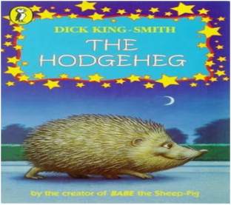,

**Computing**

During this term, the children will be looking at computing systems and networks. They will be looking at how to search the web effectively and selecting reliable search results. In addition to this, the children will be finding out how to communicate responsibly online.

**English**

This term our topic will be The Vikings. The children will read and respond to written facts and stories to develop their comprehension skills. They will be learning to write character descriptions and myths. Spellings will be tested weekly. We will continue to emphasise the importance of presentation and handwriting. In addition to this, we will be studying different aspects of grammar.

**Maths**

The children will be developing their knowledge of addition, subtraction, multiplication and division. Alongside this, they will be securing and extending their understanding of units of measurement, algebra. The children will continue to revise and improve arithmetic skills and develop their reasoning methods.

**Overview of Spring Term 1: *Year 6***

**Year**

**Yr**

**YEAR**

**Science**

We will be looking at the topic

of electricity. Children will Compare and give reasons for why components work and do not work in a circuit. They will also draw circuit diagrams using correct symbols. In addition to this, children will know how the number and voltage of cells in a circuit links to the brightness of a lamp or the volume of a buzzer.

**RE/PSHE**

We will be looking at the topics of:

RE – Is it better to express your religion in arts and architecture or in charity and generosity?

PSHE – Money Matters

**Art/Design Technology**

We will be using Viking weaponry and the runic alphabet as a stimulus for our own creative work. Children will attempt to make their own bow and arrow!

**PE**

Mr Oliver will teach the children PE during PPA time on a Monday afternoon. They will be working on team games including invasion games.

**Music**

The children will begin a 10 week workshop called Bamboo Tamboo, where they will learn the art of bamboo drumming and different rhythmic patterns!

***IMPORTANT INFORMATION***

* Homework will be given out weekly on a Wednesday and is due back in on a Monday.
* Spellings will be given out on a Wednesday and tested the following Tuesday.
* Inset day – Monday 24th February 2025.
* Viking day – Thursday 13th February 2025. (More details to follow).
* SATs week 13th – 17th May 2023.

Miss Williamson and Mr Palfreyman

**History**

We will look at life during the Viking period and compare life then, to modern day life. We will study Viking beliefs, weaponry, the attack on Lindisfarne, Viking longships and the runic alphabet.

**Geography**

We will look at the geography of Scandinavia and explain why human activity has caused the environment to change.