**AUTUMN 1 Newsletter**

***Welcome to Year 5!***

***We are really looking forward to an exciting half term of learning!***

**Year**

**Yr**

**YEAR**

**English**

Linked to our topic, this term we will be reading The Explorer by Katherine Rundell. If the children have a copy of the book at home, they are welcome to bring it to school to read along.

In Shared Reading, the children will focus on different weekly texts, generating and answering questions about the text as well as making predictions.

Your child is welcome to change their reading book every day. We will be checking their reading diaries once a week. Children who have read 3 times or more at home will receive two bronze stickers.

In writing, our work will focus around the theme of Brazil and the Amazon Rainforest. During the first block of work the children will be creating a fact-file, using persuasive writing techniques and taking part in debates. Our second genre will be explanation texts.

We will be learning weekly spellings. The spellings are taken from a National Scheme of work and are linked to Year 3 learning.

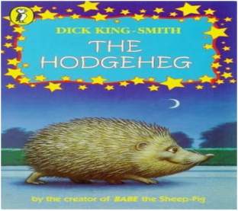

**Science**

The children will be developing their scientific and investigative skills through a range of learning opportunities. We will be looking at the topic, ‘Properties and Changes of Materials’.

***Notes***

* Please send in a healthy snack at morning break.
* Homework and spellings will be given out on aThursday, to be **handed in by Wednesday. The spelling test is every Thursday.**
* All the children will be taking part in a clarinet lesson every Wednesday afternoon. This is such an exciting opportunity for Year 5! (Instruments will be provided by school).
* *Please ensure that school jumpers and cardigans are labelled*. A biro will do.
* Friday is *Feel Good Friday* in year 5. As part of this, the children are invited to bring slippers to school to wear during the day. These can be kept at school if you wish

**Computing**

The children will be using the internet for rainforest research.We will then use this information to create fact-files using a word processor.

We will also be looking at programming.

**Mathematics**

During this term, the children will focus on place value and the four operations of number (addition, subtraction, multiplication and division). Alongside this, we will also be developing the children’s recall of times table facts through fluency and TTRS practise. Your child’s login details will be sent home so that they can practice their fluency.

.

**Art**

Our focus this half term will be on Henri Rousseau. We will be looking at recreating some of his most famous work. This will be achieved by creating a wash with water colours and then perfecting our animal sketches.

**PE**

Mr Oliver will take the children for their PE lessons every Tuesday morning.

**Geography**

We will be investigating where the cocoa bean is found and researching geographical information about Brazil, with a particular focus on the Amazon Rainforest and why we need to protect it.

The children will also become the new Mr Cadbury and learn all about fair trade.

**RE/PSHE**

* In our RE lessons this half term we are looking at why people might believe in God.
* Our PSHE sessions are focussing on difference and diversity and what makes us special.