**AUTUMN 2 Newsletter**

***Welcome to Autumn 2***

***We are really looking forward to an exciting half term of learning!***

**Year**

**Yr**

**YEAR**

**English**

This term we will be reading a range of short stories, including those with a Christmas theme

In Shared Reading, the children will focus on different weekly texts, generating and answering questions about the text as well as making predictions.

Your child is welcome to change their reading book every day. We will be checking their reading diaries once a week. Children will receive one bronze sticker for each day they read.

In writing, our work will focus around the theme of chronological reports. Newspapers will take a starring role, where the children will become news reporters to solve and report a crime

We will be learning weekly spellings. The spellings are taken from a National Scheme of work and are linked to Year 5 learning.

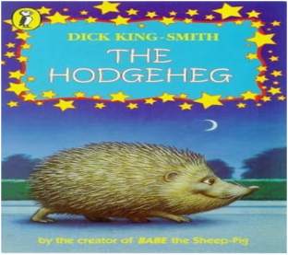

**D&T**

Following our trip to the MAD Museum, we will be designing and making marble runs. The children will be using their imaginations to create marvellous designs! They will be learning joining techniques and how to manipulate materials to bring their design to life.

***Notes***

* Please send in a healthy snack at morning break.
* Homework and spellings will be given out on aThursday, to be **handed in by Wednesday. The spelling test is every Thursday.**
* All the children will be taking part in a clarinet lesson every Wednesday afternoon. If you have signed the consent form, your child will bring their clarinet home to practice (lucky you!). Please ensure these are brought back into school by Tuesday.
* *Please ensure that school jumpers and cardigans are labelled*. A biro will do.
* Friday is *Feel Good Friday* in Year 5. As part of this, the children are invited to bring slippers to school to wear during the day.

**Science**

The children will be developing their scientific and investigative skills through a range of learning opportunities. We will be continuing to look at the topic, ‘Properties and Changes of Materials’.

**Computing**

The children will be using their programming skills. They will also be learning about vector drawing and manipulating objects

**Mathematics**

During this term, the children will focus on multiplication, division and fractions. Alongside this, we will also be developing the children’s recall of times table facts through fluency and TTRS practise. Your child’s login details are available for them to take home so that they can practice their fluency.

.

**RE/PSHE**

* In our RE lessons this half term we will be starting to look at the meaning of Christmas and why we celebrate.
* In PSHE we will be looking at what direct, indirect, and cyberbullying mean. We will identify when banter or other behaviour becomes unkind and explore the impact and consequences of bullying and discrimination.

**PE**

Mr Oliver will take the children for their PE lessons every Tuesday morning.

**History**

We will be looking at the gunpowder plot, Oliver Cromwell, The Roundheads and Cavaliers and The Plague. This will include crime and punishment and living conditions.